Programing Fundamental

2nd Assignment

Pro: Hafiz Muhammad Zahid

Session: 1E

Name:

Sabir Hussain

Roll no:

BCSM-f19-262

Q: 1 We need to perform calculations according to the following equations. You are supposed to write function for each equation where the small letters are parameters.



**Program:**

#include<iostream>

#include<conio.h>

using namespace std;

float ansZ (float, float, float, float, float, float);

int main ()

{

float a, b, c, q, r, m, z;

cout<<"Enter the value of 'a' = ";

cin>>a;

cout<<"Enter the value of 'b' = ";

cin>>b;

cout<<"Enter the value of 'c' = ";

cin>>c;

cout<<"Enter the value of 'q' = ";

cin>>q;

cout<<"Enter the value of 'r' = ";

cin>>r;

cout<<"Enter the value of 'm' = ";

cin>>m;

cout<<" Value of z = "<<ansZ (a, b, c, q, r, m);

cout<<endl;

system("pause");

return 0;

}

float ansZ (float a2, float b2, float c2, float q2, float r2, float m2)

{

float z;

z = (8.8*(a2+b2) *2/c2-0.5+2*a2/(q2+r2))/((a2+b2) *(1/m2));

return z;

}

**Output console:**

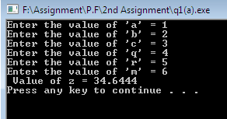

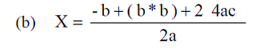

**Program:**

**#include<iostream>**

**#include<conio.h>**

**using namespace std;**

**float ansX (float, float, float);**

**int main ()**

**{**

**float a, b, c;**

**cout<<"Enter the value of 'a' = ";**

**cin>>a;**

**cout<<"Enter the value of 'b' = ";**

**cin>>b;**

**cout<<"Enter the value of 'c' = ";**

**cin>>c;**

**cout<<" Value of X = "<<ansX (a, b, c);**

**getch ();**

**return 0;**

**}**

**float ansX (float a1, float b1, float c1)**

**{**

**float X;**

**X= (-b1+(b1*b1) +24*a1*c1)/(2*a1);**

**return X;**

**}**

**Output console:**

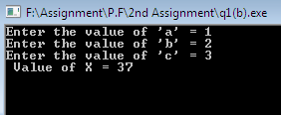

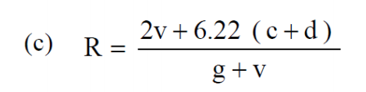

**Program:**

**#include<iostream>**

**#include<conio.h>**

**using namespace std;**

**float ansR (float, float, float, float);**

**int main ()**

**{**

**float v, d, c, g;**

**cout<<"Enter the value of 'v' = ";**

**cin>>v;**

**cout<<"Enter the value of 'c' = ";**

**cin>>c;**

**cout<<"Enter the value of 'd' = ";**

**cin>>d;**

**cout<<"Enter the value of 'g' = ";**

**cin>>g;**

**cout<<"\n\n Value of R = "<<ansR (v, d, c, g);**

**getch ();**

**return 0;**

**}**

**float ansR (float v1, float d1, float c1, float g1)**

**{**

**float R;**

**R = (2*v1+6.22*(c1+d1))/((g1+v1));**

**return R;**

**}**

**Output console:**

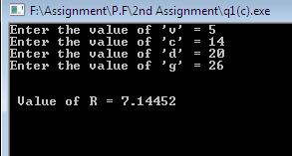

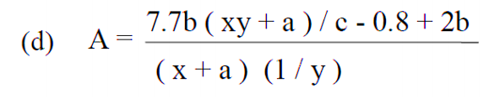

**Program:**

**#include<iostream>**

**#include<conio.h>**

**using namespace std;**

**void ansA (float a1, float b1, float x1, float y1, float c1)**

**{**

**float A;**

**A = (7.7*b1*(x1*y1+a1)/c1-0.8+2*b1)/((x1+a1) *(1/y1));**

**cout<<" Value of A = "<<A;**

**}**

**int main ()**

**{**

**float a, b, c, x, y;**

**cout<<"Enter the value of 'x' = ";**

**cin>>x;**

**cout<<"Enter the value of 'y' = ";**

**cin>>y;**

**cout<<"Enter the value of 'a' = ";**

**cin>>a;**

**cout<<"Enter the value of 'c' = ";**

**cin>>c;**

**cout<<"Enter the value of 'b' = ";**

**cin>>b;**

**ansA (a, b, x, y, c);**

**getch ();**

**return 0;**

**Output console:**

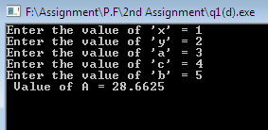

**}**

**Q: 2** Write C program for the following:

**(a)** Write a function that takes distance between two cities (in km.) and the function converts and prints this distance in meters, feet, inches and centimeters.

**Program:**

**#include<iostream>**

**#include<conio.h>**

**using namespace std;**

**void distance(float);**

**int main ()**

**{**

**float d;**

**cout<<"Enter distance between two cities (in km.) = ";**

**cin>>d;**

**cout<<endl<<endl;**

**distance(d);**

**getch ();**

**return 0;**

**}**

**void distance (float D)**

**{**

**cout<<" Distance between two cities (in meters) = "<<1000.0*D<<" m"<<endl;**

**cout<<" Distance between two cities (in feets) = "<<3280.84*D<<" ft"<<endl;**

**cout<<" Distance between two cities (in inches) = "<<39370.1*D<<" inch"<<endl;**

**cout<<"Distance between two cities (in centimeter) = "<<100000.0*D<<" cm"<<endl;**

**Output console:**

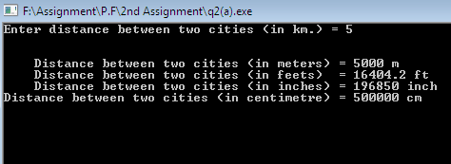

**}**

**(b)** Two numbers are input through the keyboard into two locations C and D. Write a function to interchange the contents of C and D. (Hint: Use parameter by reference).

**Program:**

**#include <iostream>**

**#include<conio.h>**

**using namespace std;**

**void swap (float &x, float &y)**

**{**

**float temp;**

**temp=x;**

**x=y;**

**y=temp;**

**}**

**int main ()**

**{**

**float C, D;**

**cout<<"Enter the 1st Number = ";**

**cin>>C;**

**cout<<"Enter the 2nd Number = ";**

**cin>>D;**

**cout<<endl<<endl;**

**cout << "Before swap, value of 1st no :" << C << endl;**

**cout << "Before swap, value of 2nd no :" << D << endl;**

**swap (C, D);**

**cout<<endl<<endl;**

**cout << "After swap, value of 1st no :" << C << endl;**

**cout << "After swap, value of 2nd no :" << D << endl;**

**return 0;**

**Output console:**

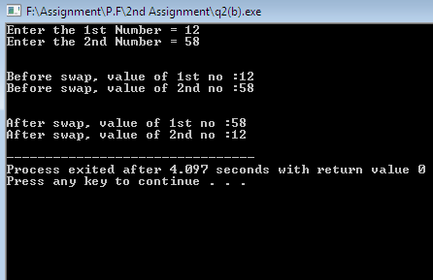

**}**

**Q: 3** Write a function to calculate overtime pay of 10 employees where the number of working hours is given to function in an array. Overtime is paid at the rate of Rs. 12.00 per hour for every hour worked above 40 hours. Assume that employees do not work for fractional part of an hour.

**Program:**

**#include <iostream>**

**#include<conio.h>**

**using namespace std;**

**void overtimePay (void)**

**{**

**int ovt [10];**

**double pay [10];**

**cout<<endl<<endl;**

**cout<<"Enter the Working hour’s of 10 Employees in a week \n\n";**

**for (int j=0; j<=9; j++)**

**{**

**cout<<j+1<<" Employee working hour's = ";**

**cin>>ovt[j];**

**pay[j]=0;**

**if(ovt[j]>40)**

**{**

**pay[j]=(ovt[j]-40) *12;**

**}**

**}**

**cout<<"\n\n******************************************************* \n";**

**cout<<"\t \t Weekly Overtime Pay of an Employees \n\n";**

**for (int k=0; k<=9; k++)**

**{**

**cout<<k+1<<“ Employee Overtime Pay = "<<"Rs. "<<pay[k];**

**cout<<endl;**

**}**

**cout<<"\n\n *******************************************************";**

**}**

**int main ()**

**{**

**cout<<"\t \t Weekly Overtime Pay of an Employees";**

**cout<<endl<<endl;**

**overtimePay ();**

**cout<<endl;**

**system("pause");**

**return 0;**

**}**

**Output console:**

